HEARTSAFE
Application for Designation as a
Community

To be designated a HEARTSAFE Community, a neighborhood, business, school, church or other “community” must simply following the steps below. There is no cost except in time and commitment, but the rewards are lives saved.

- Chose a local HEARTSAFE Champion who will be our contact person for the program

- Offer periodic Hands Only™ CPR+AED training to your community with a goal of at least 10% of all residents trained

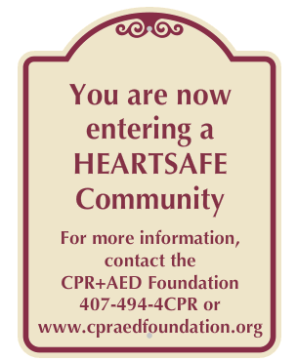
- Have at least one 911 registered AED for every 200 residents, located either with a resident, in a clubhouse or in a recreation facility

- Check nearby buildings for AEDs and make sure they are 911 registered

- Promote CPR & AEDs for pools in the community

- Renew these requirements every three (3) years

- Your community will receive signs to be placed at each entrance designating it "A HEARTSAFE Community”

- Complete the application & email to: info@cpraedfoundation.org

We would like to be a HEARTSAFE Community

Name of Community _______________________________________________
Type of community:
- Neighborhood
- Business
- School
- Church
- Other_________________________________________________________

Contact info:
Name___________________________________________________________
Title_____________________________
Address__________________________________________________________
City_______________________________________State______Zip_________
Best Phone_______________________________________________________
Email___________________________________________________________

How many entrances are there to your community?_______________________

Comments or questions:

